

Faculty of Engineering

Computer and Systems Engineering Department

**CSE 371: Control Systems (1)**

Instructor: Prof. Wahied Gharieb Ali

Micro-project

**PID controller**

**Submitted by**

Magdy Mohamed Abdel Moneim Hafez ID: 33800

Mohamed Ismail Mohamed Hafez ID: 33808

Sherif Ahmed Hassan Kotb ID: 33762

Shady Hany El Sayed Mohamed ID: 33760

Marco Emile Ramzy Andraws ID: 33794

Fall (2015-2016)

***Table of Contents***  Topic……………………………………………..……..……Page number

1) Problem Formulation …………………………………………………………..

2) Background……………………………………………………………………….. 3

3) Calculations………………………………………………………………………...4

3) Simulink results …………………………………………………………………..5

4) Conclusion…………………………………………………………………………. 9

5) References ………………………………………………………………………..10

***Problem Formulation***

* Given an open loop transfer function and then asked to simulate the closed loop unity feedback and PID controller using Simulink
* We should determine which parameter of the PID controller decreases the settling time.
* Studying the effect of disturbance on the system.
* Computing the Phase and Gain margins of open loop system and closed with PID controller.

***Background***

* The PID is the most popular feedback controller algorithm used. It is a robust easily understood algorithm that can provide excellent control performance despite the varied dynamic characteristics of processes.
* The PID algorithm consists of three basic modes:

The Proportional mode, the Integral mode & the

Derivative mode.

* When utilizing the PID algorithm, it is necessary to decide which modes are to be used (P, I or D) and then specify the parameters (or settings) for each mode used.
* Generally, four basic algorithms are used: P, PI,PD or PID.
* Controllers are designed to eliminate the need for continuous operator attention.
* Cruise control in a car and a house thermostat are common examples of how controllers are used to

automatically adjust some variable to hold a measurement

(or process variable) to a desired variable (or set-point)

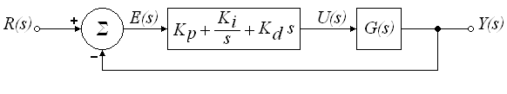

In the *s*-domain, the PID controller may be represented as:



And in time domain:



The signal *u(t)* will be sent to the plant, and a new output *y(t)* will be obtained. This new output *y(t)* will be sent back to the sensor again to find the new error signal *e(t).* The controllers takes this new error signal and computes its derivative and its integral gain. This process goes on and on.

***Calculations***

d) Closed loop with PID = $\frac{93.3s^{2}+121.3s+39.42}{3.077s^{4}+18.46s^{3}+15.39 s^{2}}$

***Simulink Results***

a)

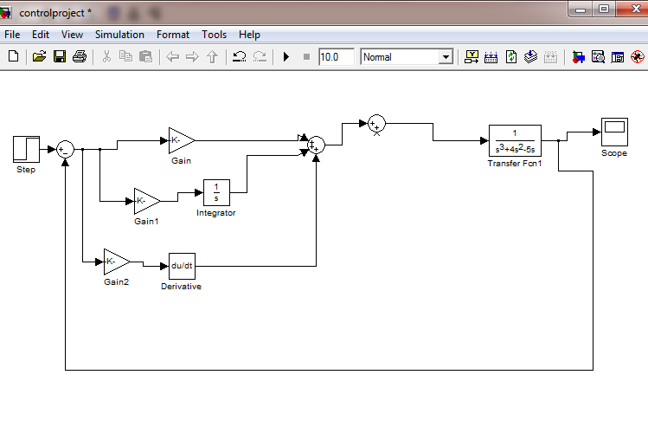

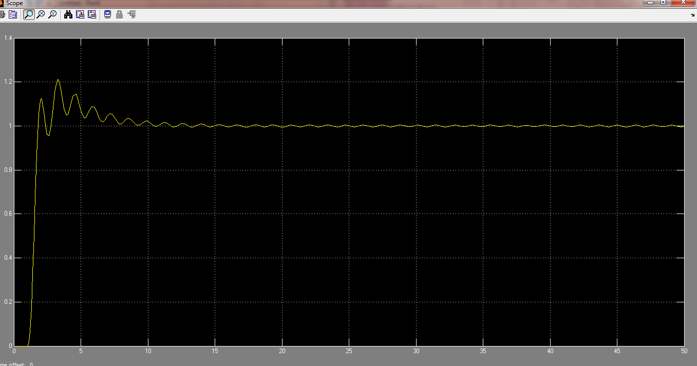

b) When increasing the **derivative term**, this makes the system better damped and more stable, also decreases the settling time.

c)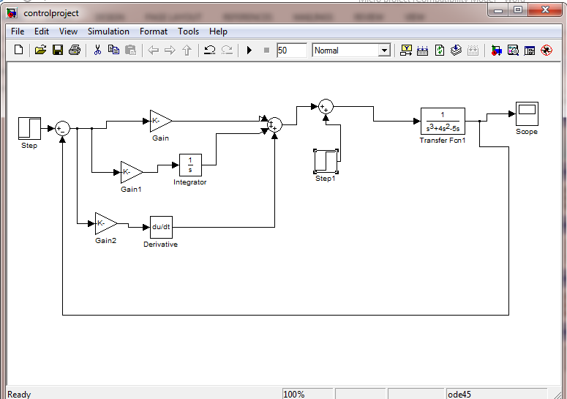

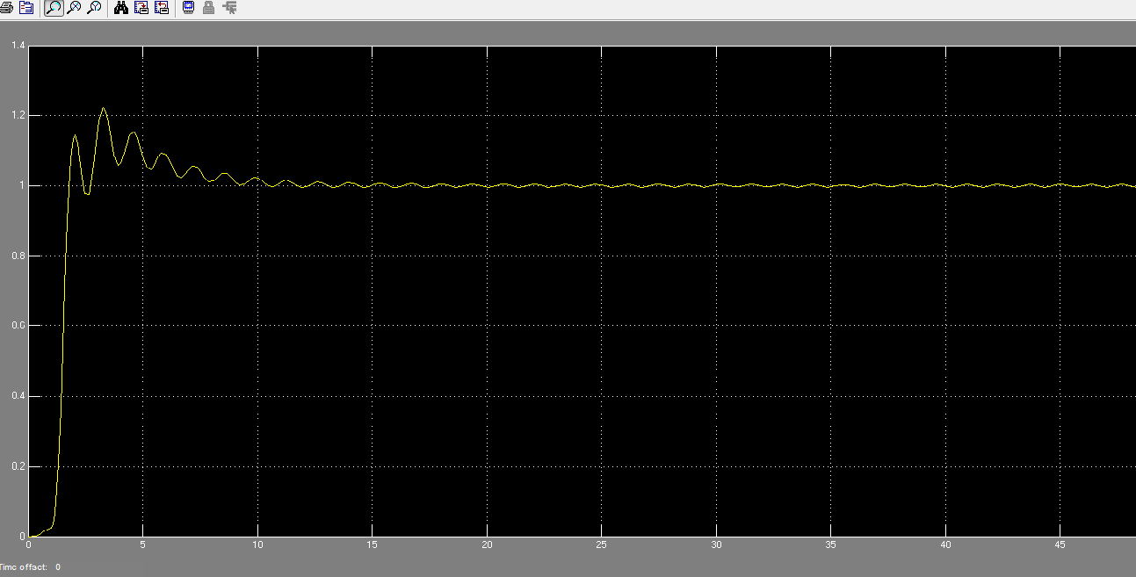

The closed loop and the PID controller eliminate the effect of constant disturbance.

d) Open loop:

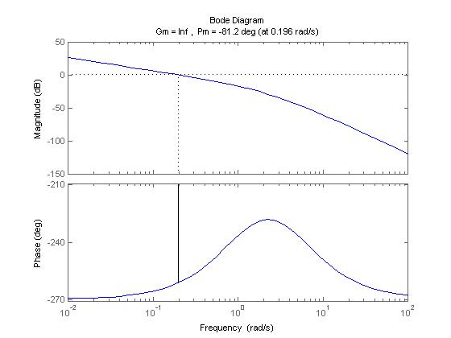

Gain margin=∞

Phase margin=-81.2 degrees

Closed loop:

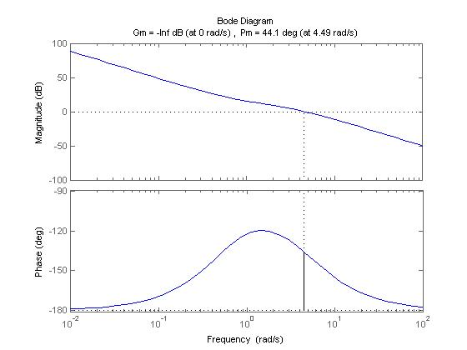

Gain margin =-∞

Phase margin = 44.1 degrees

***Conclusion***

* Increasing the derivative term decreases the settling time.
* The disturbance has no effect in PID closed loop system.
* No steady state error (due to integrator term).
* Proportional term decreases rise time.

***References***

* CSE 371 slides By Prof. Wahied Gharieb Ali.
* Online Matlab help sites.
* Using Matlab and Simulink.
* K. Ogata, “**Modern Control Engineering**”, Fifth edition, Prentice Hall, 2010.